**Cat and Mouse**

1. Delete Sprite 1 and add a new sprite from the sprite library (Cat 2).
2. We will create a clone of the cat by adding the following code to Cat 2 sprite.

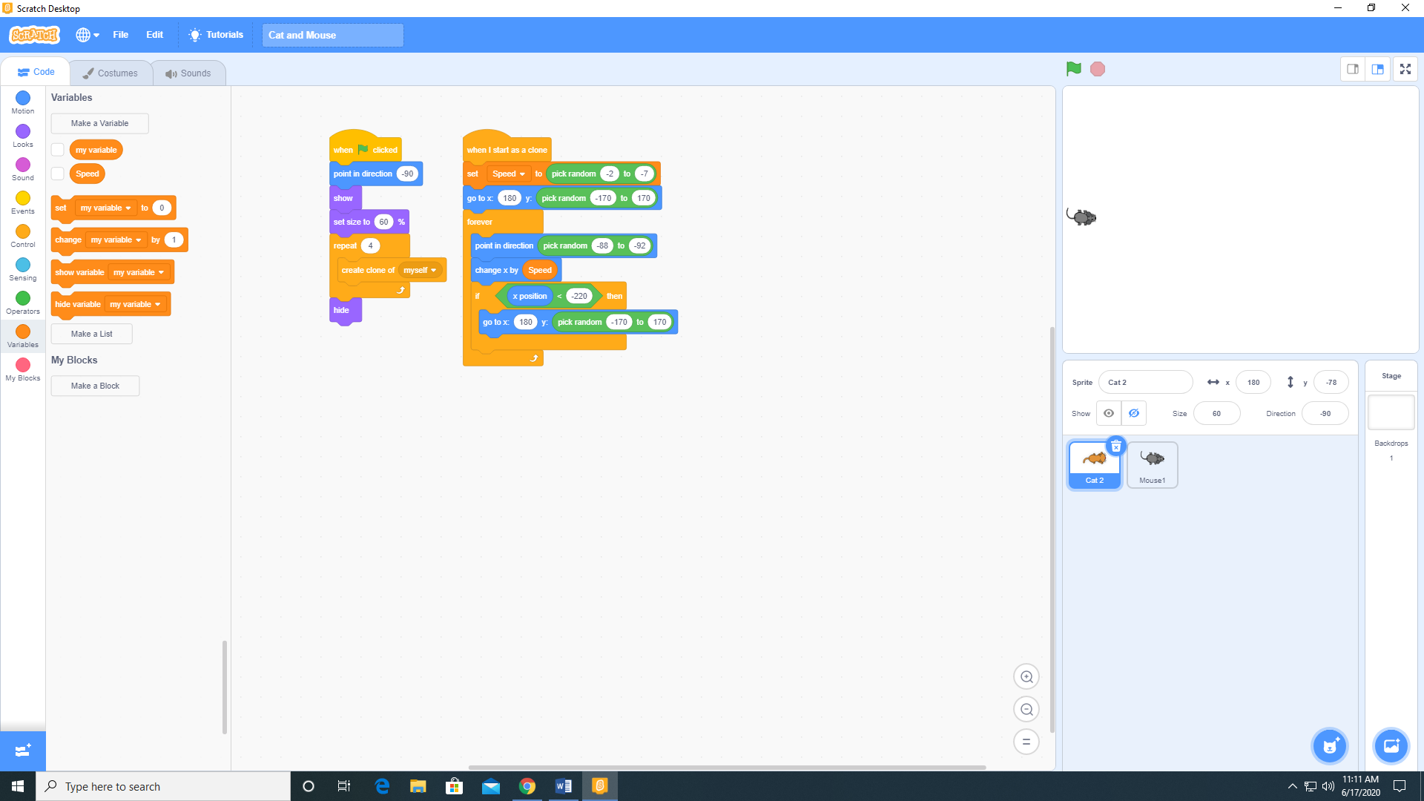

Note: This will create 4 cats. As each cat is cloned, it will execute the When I start as a clone code.

1. Add a sprite to your project from the sprite library (Mouse 1)
2. Add the Meow 2 sound from the sound library to this sprite.
3. Add the following code to the Mouse 1 sprite.

